**Lab report - 04**

*Course title: OOAD Lab*

*Course code: CSE-314*

*3rd Year 1st Semester 2022*

**Date of Submission**: 27-07-2023



**Submitted to-**

Sarnali Basak (Associate Professor)

Nadia Afrin Ritu (Lecturer)

*Department of Computer Science and Engineering*

*Jahangirnagar University*

*Savar, Dhaka-1342*

| **Name** | **Class roll** | **Exam roll** |
| --- | --- | --- |
| Umma Sumaiya Jahan | 351 | 202163 |

**Problem statement-1:**

A **company** owns **HotDog carts** that are used at the **CSE Carnival Show**. These carts sell **hotdog sausages** in a fresh **bread roll** with **sauce and/or mustard** as required. The sausages must be kept in the **fridge** until they need to be heated up. There are two places to heat hotdog sausages each with room for 10 sausages at a time. When one heating place gets low on hotdog sausages, sausages are moved to the alternate area and the original area is restocked. These are boxes of fresh rolls kept on the bench top of the cart. The hotdog sausages and the bread rolls come in boxes of 100 and there is space for 2 boxes of hotdog sausages in the **fridge.** Currently, to restock the cart, **the person** working on the cart has to pack up the cart and take it to the central store, where the storeman will get the required sausages, bread rolls, sauce or mustard. **The company** wants to improve the process of restocking the carts with hotdogs, rolls, sauce and mustard without having to move the cart from its location so that no sales are lost. If hotdog sausages get below a specific threshold, the storeroom at the Show Ground needs to be notified and then the storeman can send a person with a new box of hotdog sausages and a new box of fresh bread rolls to the cart. Sauce and mustard are kept in **dispensers** which measure out one serve per press. Sauce and mustard will also need to be managed by the proposed system.

Class diagram for the given problem statement is attached below.

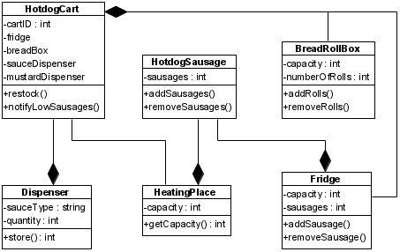

**Problem statement-2:**

Springfield **University** offers a number of courses. A **course** contains a number of units. **Students** enroll and elect a set of units every semester. Students are allowed to enroll in a maximum of 5 **units** in any given semester. They can only be enrolled into a single course at any given point in time. However, over a student's lifetime, they may undertake a number of different courses. Each unit has a set fee that is set at the start of the semester. This fee is to be paid up-front in full by the students once enrolled. Some units have prerequisite unit requirements. Some units have co-requisite unit requirements. To be enrolled in some courses, you must have completed a certain course (e.g. to enroll into a Postgraduate course, you must have an Undergraduate degree).

Class diagram for the given problem statement is attached below.

